Evaluation Of Coronary Artery Bypass Graft Using Multidetector CT Angiography Versus Conventional Coronary Angiography: Comparative Study
Abstract
Background: Standard treatment for advanced coronary artery disease is CABG surgery. Due to their short lifespan, coronary artery bypass grafts require imaging analysis. Although conventional coronary angiography is the gold standard for imaging coronary arteries and coronary artery bypass grafts, it has a number of drawbacks. Thanks to advancements in MDCT coronary angiography, it plays a crucial role in imaging coronary artery bypass grafts and permits the examination of additional post-operative problems. Aim: This study aimed to compare MDCT coronary angiography and conventional coronary angiography for CABG assessment. Patients and methods: This prospective study included 50 patients with past history of CABG surgery presented to radiology department, Benha university hospital and national heart institute. All patients were evaluated by MDCT coronary angiography as well as conventional coronary angiography as a reference. Results: 122 grafts were included in the study, 48 were arterial and 74 were venous grafts. Regarding arterial grafts, 46 were LIMA-LAD grafts, 39 of which were patent, 3 had significant stenosis and 4 were occluded. The RIMA–RCA was patent and the Radial-OM graft showed significant stenosis. Regarding venous grafts, 17 grafts were patent, 6 grafts showed significant stenosis, and 51 grafts were occluded. Conclusion: MDCT coronary angiography is a reliable non-invasive imaging tool in assessment of CABG.
Key Words: Multidetector CT – Evaluation – Coronary artery bypass grafts.

1.Introduction
Coronary artery disease is a leading global cause of death and disability. In emerging nations, the disease's prevalence is significantly expanding [1].
Coronary Artery Bypass Graft (CABG) surgery continues to be the treatment of choice for advanced coronary artery disease. Long-term clinical prognosis following surgery is contingent upon patency of bypass grafts and the advancement of native coronary artery disease [2]. Due to the limited longevity of coronary artery bypass grafts, postoperative imaging is necessary [3].
For assessing bypass grafts and native coronary arteries, conventional coronary angiography has been utilized. However, the operation is invasive and linked with risks and problems [4].
Continuous developments in CT have established cardiac CT angiography as a noninvasive imaging test of the heart, coronary arteries and coronary bypass grafts, with improving image quality and diagnostic accuracy due to high temporal and spatial resolution [5].
2.Patients and Methods:
This trial included 50 patients with past history of CABG surgery presented to radiology department, Benha university hospital and national heart institute in the period between january 2021 and october 2022. The study protocol was approved by the Medical Ethical Committee of Faculty of Medicine, Benha University and informed consent was taken from each patient.
Inclusion criteria:
Patients with previous CABG surgery who need assessment of patency of their grafts and rule out any postoperative complications, with any of the following:
- Chest pain recurrence after previous CABG surgery.
- Patient underwent previous CABG surgery and had positive results for myocardial ischemia during regular follow-up.
Exclusion criteria:
- Patients who cannot withstand CT examination duration.
- Arrhythmia patients.
- Allergy to IV contrast material or had impaired renal function with estimated GFR (eGFR) < 30.
Patients were subjected to radiological examination including ECG gated MDCT angiography of coronary arteries and conventional coronary angiography was done as a gold standard for comparison of CT results.
MDCT angiography of coronary arteries:
Patient preparation:
- All patients were subjected to history taking, clinical examination and laboratory investigations, renal functions were done for all patients before performing the study.
Instructions: Patients were given instruction to follow before examination included:
- Fasting 4-6 hours before scan but encourage water intake.
- Caffeine, smoking & exercise avoidance 12 hours before scan.
- Stop taking drugs used for impotence or pulmonary hypertension 48 hours before scan.
Heart rate control: Those with a heart rate below 65 beats per minute were scanned immediately. Those having a resting heart rate more than 65 beats per minute were administered a cardio-selective beta-blocker one hour before to the scan, assuming there were no contraindications, in order to achieve a stable low heart rate.
IV access: 18g cannula was inserted into right antecubital vein, left upper limb cannulation was avoided to avoid streak artifact from contrast material within left innominate that may interfere with evaluation of LIMA origin.
At scanner room: Patients were placed in a supine posture, with their feet entering the gantry first and their hearts in the center of the gantry. After proper skin preparation, four ECG electrodes were placed on the patient's chest and connected to the CT trigger monitor via four leads. The test was explained to the patient before to the scan, and the patient was required to practice breathing instructions prior to swallowing 5mg sublingual isosorbide dinitrate shortly prior to the scan, assuming there were no contraindications.
After performing a breathing exercise to monitor the heart rate for a 10-second breath-holding interval, the scanner automatically changed the exposure window settings for optimal temporal resolution.
Contrast medium injection: Non-ionic contrast media with low osmolarity (Ultravist 370mgI/ml) was administered into the IV cannula using a dual head powered automated injector, followed by 50-60 cc of saline. The flow rate varied between 4 and 6 ml/sec, while the volume of contrast material varied between 80 and 90 ml. Bolus monitoring was used to identify the moment at which the helical scan began following IV contrast delivery.
Scan protocol: All examinations were performed by using Dual energy 128-slice MDCT (Revolution EVO, GE Healthcare, Japan) &Dual source system 128-sclice MDCT (SOMATOM Force, Siemens Healthcare, Forchheim, Germany)
An AP and lateral scout acquisition was performed to establish the scan range of coronary CTA, which spanned from just above the clavicles to 1cm below the heart's apex. During a single inspiratory breath-hold, the scanning orientation was craniocaudal, and the ECG signal was captured concurrently. MDCT was accomplished utilizing ECG gating triggering in hindsight.
Method of acquisition:
Technique ECG-gated retrospective technique Slice thickness 0.625 mm Gantry rotation time 0.35 sec Pitch Variable Tube voltage 120 kv Tube current auto MA Kernal 30 Recon interval 0.625 mm Matrix 512 × 512
Image reconstruction:
The retrospective ECG-data was used for image reconstruction. Images were reconstructed with at 75% of R-R interval and also at the best diastolic phase. If motion artifacts were present, additional reconstructions in 5% increments and decrements of the R-R interval is performed. In patients with heart rate below 75 bpm, snapshot segment mode (SSEG) is used for image reconstruction, while in patients with heart rate above 75 bpm, snapshot Burst (SSB) or snapshot Burst Plus (SSB+) are used for image reconstruction.
Post processing: Reconstructed images were transferred to workstation (GE 4.7 Advanced workstation, GE healthcare) to review axial images and also to obtain multi-planar reformatted images at sagittal and coronal planes. Also, maximum intensity projection images, 3D volume rendered images, semitransparent 3D volume rendered images, curved MIP, and tree view projections were obtained for detailed assessment of coronary artery bypass grafts.
Image analysis:
Assessment of image quality: CT images quality was classified into good quality; no motion artifacts, acceptable quality; mild motion artifacts & poor quality; non-interpretable graft.
Assessment of bypass grafts: Globally analyzing the position and types of grafts was facilitated by the 3D volume-generated images. Axial and curved planar reformatted images aided in the evaluation of the brightness of a graft. Each bypass graft had proximal, distal, and body anastomotic sites. The presence of stenosis or blockage in grafts was assessed. The presence of stenosis was then evaluated in the grafts initially determined to be patent. Significant stenosis was defined as lumen loss between 50 and 99 percent, and moderate, non-flow-limiting stenosis was classified as lumen loss below 50 percent. Stenoses were classified according to their location inside the graft. The patency of in situ grafts was assessed by following their subclavian artery origins to their distal anastomotic locations.
Native coronary vessels were analyzed for the progression of the disease.
Detection of other CABG surgery complications: Additionally, the photos were analyzed to discover any other surgical issues that may have contributed to the patient's complaints.
Conventional coronary angiography
All patients underwent conventional coronary angiography as the standard of reference for the comparison of MDCT results.
3.Results
This study was conducted on 50 patients with past history of CBAG surgery referred for CBAG evaluation using Multi-Detector CT angiography and conventional coronary angiography.

Table (1) General characteristics of the studied patients (n = 50)
General characteristics
Age (years) | 57 ±7
Sex
Males | 40 (80)
Females | 10 (20)
Diabetes mellitus | 14(28)
Hypertension | 28(56)
Dyslipidemia | 32 (64)
Smoking | 22 (44)
Data were presented as mean ±SD or number (percentage)
122 grafts were included in the study, 48(39.3%) grafts were arterial grafts and 74 (60.7%) were venous grafts. The age of the bypass grafts varied from 2 year to 19 years since bypass surgery.
LIMA was the commonest graft in the study as LIMA-LAD representing 46 (37.7%) grafts, followed by SVG-RCA 36 (29.5%) and SVG-OM 32 (26.2%). The least frequent grafts were SVG-D 4 (3.3%), SVG-LAD 2 (1.6%), RIMA-PDA 1 (0.8%) and Radial-OM 1 (0.8%) (Table2).
Table (2) Types of different grafts (n = 122)
Graft type | n (%)
LIMA-LAD | 46 (37.7)
RIMA-PDA  Radial-OM | 1(0.8)  1(0.8)
SVG-D | 4 (3.3)
SVG-LAD | 2 (1.6)
SVG-OM | 32 (26.2)
SVG-RCA | 36 (29.5)

CTCA findings for different graft types
Regarding arterial grafts, there are more in situ arterial grafts than free arterial grafts. All LIMA grafts were in situ grafts, anastomosed distally to LAD. The other 2 arterial grafts were free grafts anastomosed proximally to ascending aorta, Right Internal Mammary Artery (RIMA) graft anastomosed distally to posterior descending artery (PDA), and radial artery graft distally to OM branch.
On evaluating the 48 arterial grafts, there were 46 LIMA-LAD grafts, 39 (84.8%) of which were patent, 3 had significant stenosis and four had total occlusion. The RIMA –RCA graft included in the study was patent & the Radial-OM graft showed significant stenosis.
Regarding venous grafts, 17(22.9%) grafts were patent, 6(8.1%) grafts showed significant stenosis, and 51(68.9%) grafts were occluded either totally or shortly after their origin.
The study included 36 SVG to RCA: 7 (19.4%) grafts of which were patent without stenosis, 3(8.3%) showed significant stenosis whereas the remaining 26 (72.2%) grafts was occluded. 32 SVG to OM: 6 (18.8%) grafts of which were patent without stenosis, 2 (6.3%) grafts showed significant stenosis while remaining 24 (75%) grafts occluded. The 2 SVG to LAD grafts were patent. 4 SVG to D: 2 (50%) grafts of which were patent without stenosis, one graft (25%) showed significant stenosis whereas the remaining graft (25%) was totally occluded.
Degree of patency of all arterial grafts: 40 (83.3%) patent, 4 (8.3%) narrow, 4 (8.3%) occluded. The occlusion rate was more in the venous grafts, constituted 68.9% of all venous grafts.

Table (3) CTCA findings for different graft types
 |  | CTCA
 | Total | Patent | Sig stenosis | Total occlusion
LIMA-LAD | 46 | 39 (84.8) | 3 (6.5) | 4 (8.7)
RIMA-RCA | 1 | 1(100) | 0(00) | 0 (0)
RADIAL-OM | 1 | 0(0) | 1(100) | 0 (0)
SVG-D | 4 | 2 (50) | 1(25) | 1 (25)
SVG-LAD | 2 | 2(100) | 0 (0) | 0 (0)
SVG-OM | 32 | 6 (18.8) | 2 (6.3) | 24 (75)
SVG-RCA | 36 | 7 (19.4) | 3(8.3) | 26 (72.2)

Data were presented as number (percentage)
In our study 5 grafts were not imaged by ICA due to failed cannulation, CTCA detected those grafts. Two of them were LIMA-LAD grafts, one showed distal significant stenosis, the other was patent. SVG-OM graft showed mid non-significant stenosis. SVG-PDA showed proximal non-significant stenosis. SVG-D showed distal significant stenosis.
Invasive Coronary Angiography findings:
Coronary angiograms revealed the same results compared to MDCT apart from 2 out of the studied 122 grafts, showed false positive result as the stenosis degree was mild (insignificant stenosis <50%) on ICA while being overestimated by CTCA as significant stenosis.

Table (4) ICA findings for different graft types
 |  | ICA
 | Total | Patent | Sig stenosis | Total occlusion
LIMA-LAD | 46 | 40 (87) | 2 (4.3) | 4 (8.7)
RIMA-RCA  RADIAL-OM | 1  1 | 1 (100)  0(0) | 0(0)  1(100) | 0 (0)  0(0)
SVG-D | 4 | 2 (50) | 1 (25) | 1 (25)
SVG-LAD | 2 | 2(100) | 0 (0) | 0 (0)
SVG-OM | 32 | 6(18.8) | 2 (6.3) | 24(75)
SVG-RCA | 36 | 8 (22.2) | 2 (5.6) | 26(72.2)
Data were presented as number (percentage)

Agreement between ICA and CTCA
An excellent agreement was observed between ICA and CTCA (Kappa = 0.971, P-value of agreement < 0.001). CTCA detected 46.7% patent grafts, 8.2% with significant stenosis, and 45.1% with total occlusion while ICA detected 48.3% patent grafts, 6.6% with significant stenosis, and 45.1% with total occlusion (Table 5).

Table (5) Agreement between ICA and CTCA findings
 | ICA | CTCA | Kappa | P-value
Patent | 59 (48.3) | 57 (46.7) | 0.971 | < 0.001*
Significant stenosis > 50% | 8 (6.6) | 10 (8.2)
Total occlusion | 55 (45.1) | 55 (45.1)
*Significant; Data were presented as number (percentage)
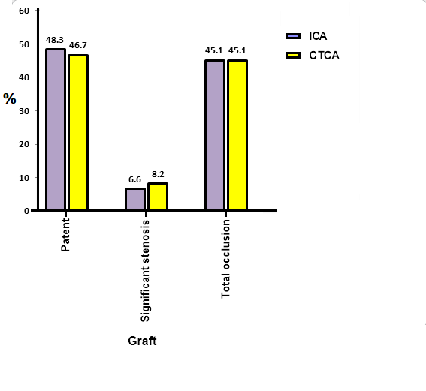
Fig (1) ICA and CTCA findings of the studied grafts
Diagnostic indices of CTCA in detecting stenotic or occluded grafts
The sensitivity, specificity, PPV, NPV, and overall accuracy of CTCA in detecting stenotic or occluded grafts were 100%, 96.7%, 96.9%, 100%, and 98.4%, respectively. ICA was used as a reference standard (Table 6).
Table (6) Diagnostics indices of CTCA in detecting stenotic or occluded grafts
 | %
Sensitivity | 100
Specificity | 96.7
PPPV | 96.9
NPV | 100
Overall accuracy | 98.4
PPV: Positive predictive value; NPV: Negative predictive value
Fig. 2. 55 years old man, diabetic, dyslipidemic and Ex-smoker with previous CABG surgery. (a) and (b) 3-D VR images showing SVG to PDA, SVG to LAD & SVG to D grafts.
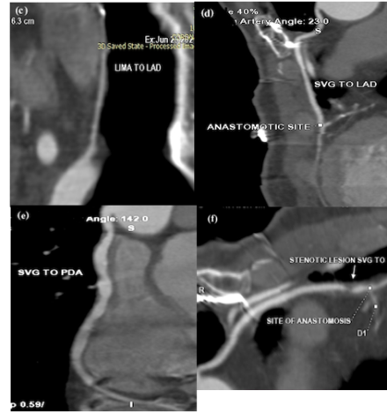
Fig. 3 MDCT of the same patient (c) curved MPR showing failed LIMA graft. (d) curved MPR showing patent SVG-LAD graft. (e) curved MPR showing non-significant proximal and mid SVG-PDA stenotic lesions. (f) curved MPR showing SVG-D graft distal significant stenosis.
Fig.4 coronary angiography of the same patient revealed ;(g) failed LIMA graft. (h) patent SVG-LAD graft. (i) SVG to RCA graft non-significant stenoses.

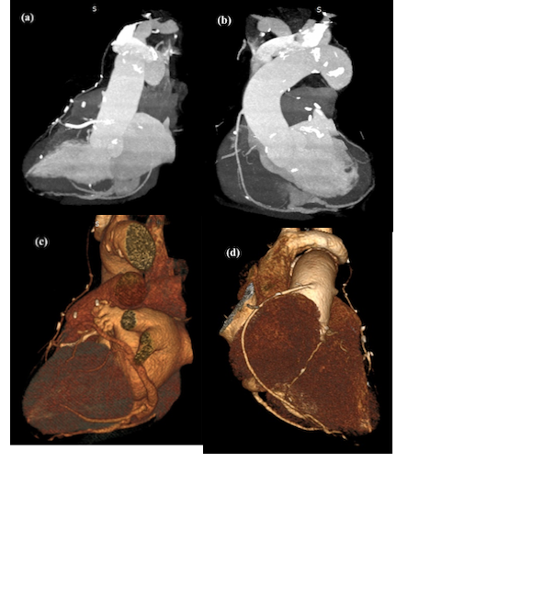
Fig.4 66 years old man, smoker, hypertensive and dyslipidemic with previous CABG surgery. (a)3D angiographic view showing patent LIMA-LAD. (b)3D angiographic view showing patent SVG-PDA graft. (c) 3D VR showing patent LIMA-LAD. (d) 3D VR showing patent SVG-PDA graft and star projection of occluded SVG to OM graft.
Fig.5 MDCT of the same patient. (e) Curved MPR showing patent LIMA-LAD graft with distal LAD intramyocardial course. (f) Curved MPR showing patent SVG-PDA graft. (g)Axial view showing significant left subclavian artery stenosis. (h)Sagittal view showing significant left subclavian artery stenosis.
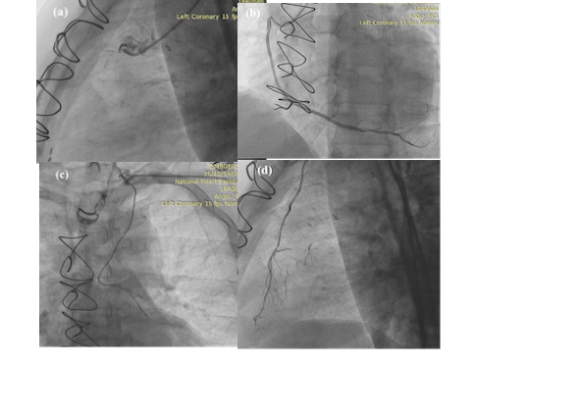
Fig.6 Conventional coronary angiography of the same patient showing occluded SVG-OM graft (a). patent SVG-PDA graft (b). (c) and (d) Left radial approach confirms the patency of LIMA-LAD graft.

4.Discussion
In patients with severe multivessel coronary disease, CABG surgery is associated with enhanced survival and quality of life. However, CABG may develop stenosis or occlusion over time [6].
While conventional coronary angiography remains the gold standard for the evaluation of coronary arteries and bypass grafts, it is still associated with a risk of serious complications. Catheter manipulations to engage the grafts are associated with an increased risk of embolic stroke or dissection, as graft engagement is technically more difficult than native vessels, due to their variable locations [7].
Improvements in MDCT coronary angiography technology have allowed its emergence as a useful tool in CABG assessment. Coronary artery bypass grafts are more amenable to CT imaging, due to their lower pulsatile movements and larger diameter than native arteries and their relative freedom from calcification [8].
Our study included 122 grafts, (39.3%) were arterial grafts and (60.7%) were venous grafts. Regarding arterial grafts, the LIMA graft was the only in-situ arterial graft included in our study, LIMA to LAD graft was the most widely used arterial graft (95.8%), with less incidence rate of complications and high patency rates. 4.2% of the arterial grafts were free arterial grafts. There was a significant narrowing in 50% of the free arterial grafts. The degree of patency of all arterial grafts was (83.3%) patent grafts, (8.3%) showed significant stenosis & (8.3%) were totally occluded. The degree of patency of LIMA grafts was (84.8%) patent, (6.5%) showed significant stenosis & (8.7%) were totally occluded.
The study of Mahmoud et al. included 63 grafts from 21 patients. (36.5%) of bypass grafts were arterial whereas (63.5%) were venous grafts. LIMA graft was the commonest arterial graft representing (91.3%) [9].
El Gerby et al. included 120 grafts, (38.3%) of the included grafts were arterial and (61.6%) were venous. Out of the arterial grafts, (78.2 %) were patent, (13%) were significantly narrowed and (8.8%) were occluded. Degree of patency of arterial grafts: (78.2%) were patent, (13%) showed significant stenosis and (8.8%) were occluded. Degree of patency of in-situ arterial grafts; (82%) were patent, (10.2%) were significantly stenosed and (7.8%) were occluded. For the LIMA grafts; (84.8%) were patent, (9%) were significantly narrowed and (6.2 %) were occluded. (57%) of free grafts were patent, (28.5%) were narrow and (14.5%) occluded [10].
Gorantla et al., in 2012 included 89 grafts, (37.2%) were arterial grafts and (61.8%) were venous grafts. Among the arterial grafts, 88.2% were patent and 11.8% were occluded [1].
Regarding the current work, venous grafts were the most common type of included grafts, representing 60.6%. There was a high rate of complications with venous grafts owing to their high rate of occlusion and narrowing. Our study showed that (22.9%) of venous grafts were patent, (68.9%) were totally occluded, and (8.1%) were significantly narrowed. The RCA was the commonest site for venous graft landing representing (48.6%) followed by the obtuse marginal branch (34.2%) then the diagonal branch 5.4% & LAD 2.7%. The most commonly occluded venous graft was connected to RCA where 26 grafts were occluded representing 35% of the examined venous grafts.
In the study of Mahmoud et al., (63.5%) of grafts were venous. Out of them, (27.5%) grafts were patent, 7.5% were significantly narrowed and 65% of them were occluded. This gives a high rate of complications of about 72.5%, while the patency rate of arterial grafts was higher [9].
In the study of El Gerby et al., (70.2 %) of venous grafts were patent, (19 %) of venous grafts were considerably narrowed and (10.8 %) were occluded [10].
In the study of Gorantla et al., 55 venous grafts were included. (72.7%) of them were patent and (27.3%) were occluded [1].
Our study included 36 SVG to RCA grafts, (19.4%) were patent, (8.3%) showed significant stenosis and (72.2%) grafts were occluded. 32 SVG to OM grafts: (18.8%) were patent, (6.3%) showed significant stenosis and (75%) were occluded. The 2 SVG to LAD grafts included in this study were patent. 4 SVG to D: (50%) grafts of which were patent, (25%) showed significant stenosis and (25%) occluded.
In study of Mahmoud et al., regarding SVG to PDA grafts: (30%) were patent without stenosis whereas (70%) of grafts were occluded. The included 4 SVG to LAD grafts were occluded. Regarding SVG to Diagonal grafts: (37.5%) of grafts were patent and (62.5%) of grafts were occluded. Regarding SVG to OM grafts: (27.8%) of grafts were patent, (16.7%) of grafts showed significant stenosis, and (55.5%) were occluded. The most commonly occluded venous graft was connected to OM branch representing 25% of the examined venous grafts. SVG to OM was also the most common graft that showed significant stenosis representing 7.5% of the examined venous grafts [9].
In our study, the occlusion rate was higher in the venous grafts and the lifetime of the graft patency was considerably good in the arterial graft.
In our study, the diagnostic statistics of sensitivity, specificity, PPV, NPV, and overall accuracy of CTCA in detecting stenotic or occluded grafts were 100%, 96.7%, 96.9%, 100%, and 98.4%, respectively. Our study results are in accordance with the previous studies of MDCT, which demonstrated a high diagnostic accuracy in identification of graft stenosis and occlusion.
Our results are in accordance with Weustink et al. who evaluated 58 patients with 64-slice MDCT. Sensitivity, specificity, positive predictive value, and negative predictive value were 100%, 96%, 97%, and 100% for all grafted vessels, respectively. [11]
Our results are also comparable and coincide with the study of El Gerby et al. conducted on 50 patients, the sensitivity, specificity & diagnostic accuracy of the MDCT coronary angiography in the evaluation of coronary artery bypass grafts patency were 100%, 98%& 93.6% respectively [10].
Our results are also in accordance with a study of Mahmoud et al. conducted in 2020 on 36 CABG patients, the sensitivity & specificity of MDCT in evaluation of coronary artery bypass grafts stenosis or
Our results are also in agreement with Romagnoli et al. and Monem et al. as using ECG-gated 64-rows MDCT coronary angiography. According to their findings multi–detector row CT angiography presented a good diagnostic performance, regarding the assessment of occlusion or stenosis of the grafts (sensitivity: 100 % & specificity: 97% in Romagnoli et al. study) and (sensitivity 100 % and specificity 96.4% in Monem et al. study) [12] [13].
Sahiner et al. investigated 284 patients with a total of 684 bypass grafts, whereas Andreini et al. examined 119 patients with 277 bypass grafts. Both studies reported a sensitivity, specificity and negative predictive values of more than 97 % [14] [15].
In 2008, Hamon et al. performed a meta-analysis of 15 studies published between 2004 and 2007 to evaluate the accuracy of 16-and 64-section spiral Computed Tomography to assess coronary artery bypass grafts. The results of their meta-analysis demonstrate that obstructive bypass graft disease can be detected by using at least a 16-section CT with a high diagnostic accuracy (90% and 96% for 16- and 64-slice MDCT, respectively), overall sensitivity of 97.6% and overall specificity of 96.7%, a positive predictive value of 92.7% and a negative predictive value of 98.9% [16] .
Our results agreed to some extent with a meta-analysis of Chan et al., in 2016 that evaluated the diagnostic accuracy of 64-slice and upward MDCT versus ICA in the diagnosis of graft occlusion or stenosis. Thirty-one studies were included, involving 1,975 patients with 5,364 assessed grafts. Assessment of grafts for stenosis or occlusion demonstrated sensitivity of 96.1%, specificity of 96.3%, positive predictive value of 94.3%, and negative predictive value of 99%. Two studies conducted with over-64-slice MDCT (respectively with 128-slice and 256-slice) showed no significant improvement in sensitivity but a greater specificity (98.5% vs. 96.1%) [17].
In the study of Nazeri et al in 2009, a total of 287 grafts (89 arterial grafts, 198 venous grafts) were evaluated using 64-slice computed tomographic angiography for the detection of significant stenosis. Sensitivity, specificity, and positive and negative predictive values of 64-slice CT for the detection of significant lesions in bypass grafts were 98%, 97%, 96%, and 99%, respectively [18].
MDCT offers 3D volume rendered images that give much anatomical and pathological details in contrast to conventional angiography that only visualize lumen. MDCT define accurately the origin of the grafts and offers precise information about the position of the existing grafts, in our study 5 grafts were failed cannulation by ICA, while being detected by CTCA.
5.Conclusion
Multidetector coronary CT angiography is a useful tool in assessment of coronary artery bypass grafts as it offers high diagnostic accuracy in the CABG evaluation and should be recognized as an accurate and non-invasive method for assessment of graft patency in patients after CABG.
6.References
- R. Gorantla, J. S. N. Murthy, T. R. Muralidharan, R. Mandava, B. Dev, H. Chandaga, & S. Joseph, Diagnostic accuracy of 64-slice multidetector computed tomography in evaluation of post-coronary artery bypass grafts in correlation with invasive coronary angiography. Indian Heart Journal. Vol. 64(3),pp. 254-260,2012.
- A. A. Frazier, F. Qureshi, K. M. Read, R. C. Gilkeson, R. S. Poston, & C. S. White, Coronary artery bypass grafts: assessment with multidetector CT in the early and late postoperative settings. Radiographics .vol. 25(4),pp. 881-896.,2005.
- F. Jungmann, T. Emrich, P. Mildenberger, A. L. Emrich, C. Düber, & K. F Kreitner. Multidetector computed tomography angiography (MD-CTA) of coronary artery bypass grafts–Update 2017. In RöFo-Fortschritte auf dem Gebiet der Röntgenstrahlen und der bildgebenden Verfahren (Vol. 190, No. 03, pp. 237-249). © Georg Thieme Verlag KG,2018.
- S. A. Khedr, M. A. Hassaan, & M. H. Allam, Diagnostic value of MDCT angiography in assessment of coronary artery bypass graft. The Egyptian Journal of Radiology and Nuclear Medicine.vol.44(2),pp. 183-191,2013.
- T. Henzler, P. Carrascosa, B. S. Ko, & R. Rubinshtein, Principles of Cardiac CT Image Acquisition. In CT of the Heart (pp. 69-85). Humana, Totowa, NJ. ,2019.
- A. Ascarelli. Role of multidetector CT in the evaluation of coronary artery bypass grafts. Imaging in Medicine.vol.2(1), pp.77,2010.
- A. M. Beirne, K. S. Rathod, E. Castle, M. Andiapen, A. Richards, A. Bellin,... & D. A. Jones, The BYPASS-CTCA Study: the value of Computed Tomography Cardiac Angiography (CTCA) in improving patient-related outcomes in patients with previous bypass operation undergoing invasive coronary angiography: Study Protocol of a Randomised Controlled Trial. Annals of Translational Medicine. Vol. 9(17), 2021.
- R. H. Donkol, Z. S. Mahmoud, & M. Elrawy, Evaluation of Coronary Artery Bypass by CT Coronary Angiography. In Coronary Artery Bypass Graft Surgery. IntechOpen,2017.
- A. D. Mahmoud, R. A. Alarabawy, A. A. Mubarak, & M. Taymour. Evaluation of Coronary Artery Bypass Graft Using Multi-Detector CT Angiography: Comparative Study. The Medical Journal of Cairo University.vol. 88(March),pp. 285-294,2020.
- K. M. El Gerby, M. I. Amin, , & M. I. Amin Mousa, Assessment of the role of 128 row multi detector computed tomography in the evaluation of coronary artery bypass grafts patency. Zagazig University Medical Journal.vol. 24(2),pp. 166-177,2018.
- A. C. Weustink, K. Nieman, F. Pugliese, N. R. Mollet , B. W. Meijboom, C. van Mieghem, & P. J. de Feyter, Diagnostic accuracy of computed tomography angiography in patients after bypass grafting: comparison with invasive coronary angiography. JACC: Cardiovascular imaging. Vol.2(7), pp.816-824,2009.
- A. Romagnoli, A. Patrei, A. Mancini, C. Arganini, S. Vanni, M. Sperandio, & G. Simonetti, Diagnostic accuracy of 64-slice CT in evaluating coronary artery bypass grafts and of the native coronary arteries. La radiologia medica. vol. 115(8), pp.1167-1178,2010.
- S. A. Monem, A. M. Nasr, A. M. Algebalay, I. M. Helmy, & M. S. Eldin, Sixty four multi-detectors CT coronary angiography: An easy and accurate method to detect graft patency post CABG. The Egyptian Journal of Radiology and Nuclear Medicine. vol. 43(3),pp. 377-381,2012.
- L. Şahiner, U. Canpolat, H. Yorgun, T. Hazırolan, M. Karçaaltıncaba, H. Sunman, & A. Oto, Diagnostic accuracy of dual-source 64-slice multidetector computed tomography in evaluation of coronary artery bypass grafts. Journal of Investigative Medicine. Vol. 60(8),pp. 1180-1185,2012.
- D. Andreini, G. Pontone, S. Mushtaq, A. Annoni, A. Formenti, E. Bertella, & M. Pepi. Diagnostic performance of two types of low radiation exposure protocol for prospective ECG-triggering multidetector computed tomography angiography in assessment of coronary artery bypass graft. International journal of cardiology. vol. 157(1),pp. 63-69,‏ 2012.
- M. Hamon, O. Lepage, P. Malagutti, J. W. Riddell, R. Morello, D. Agostini, & M. Hamon. Diagnostic performance of 16-and 64-section spiral CT for coronary artery bypass graft assessment: meta-analysis. Radiology. Vol. 247(3),pp. 679-686,2008.
- M. Chan, L. Ridley, D. J. Dunn, D. H. Tian, K. Liou, J. Ozdirik, & C. A. Cao. systematic review and meta-analysis of multidetector computed tomography in the assessment of coronary artery bypass grafts. International journal of cardiology. vol. 221,pp. 898-905,2016.
- I. Nazeri, P. Shahabi, M. Tehrai, B. Sharif-Kashani, & A. Nazeri. Assessment of patients after coronary artery bypass grafting using 64-slice computed tomography. The American journal of cardiology. vol. 103(5),pp. 667-673,2009.

